Perform Following Query using Employee Table. (Retrieving Data)

- List all distinct job in Employee.

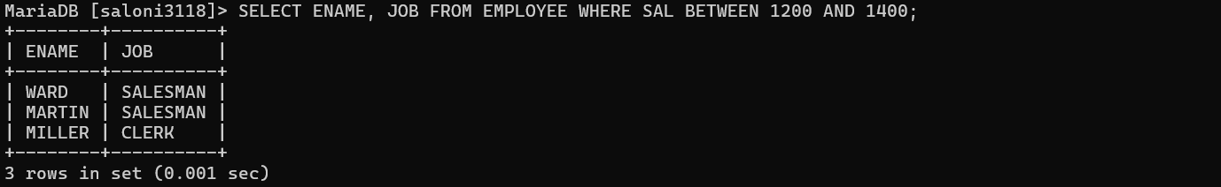

- List all information about employee in Department Number 30

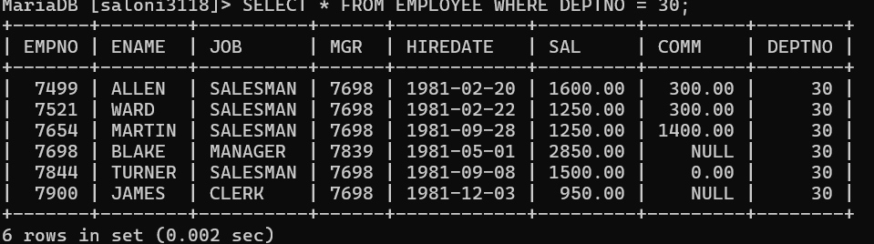

- Find all department number with department names greater than 20.

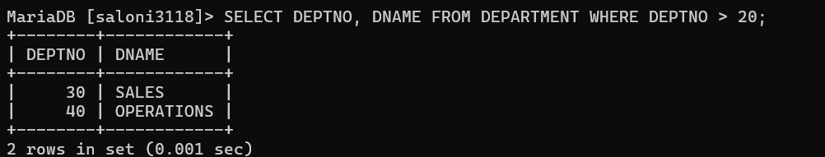

- Find all information about all the managers as well as the clerks in department 30.

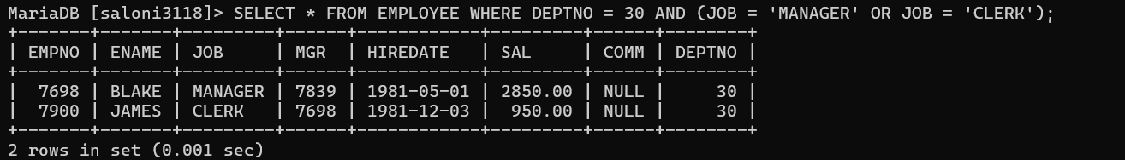

- List the Employee name, Employee numbers and department of all clerks.

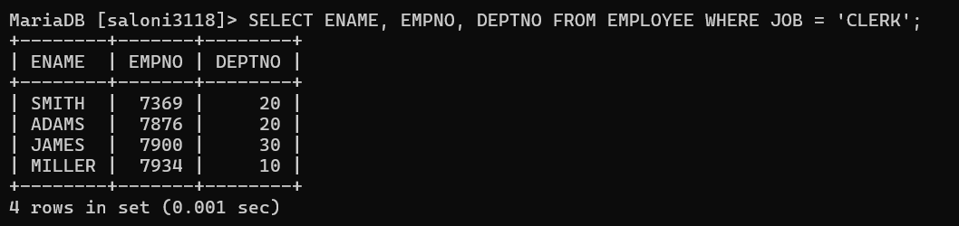

- Find all managers not in department 30.

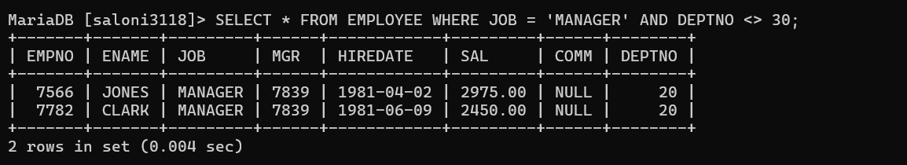

- List information about all Employees in department 10 who are not manager or clerks.



- Find Employees and jobs earning between 1200 and 1400.

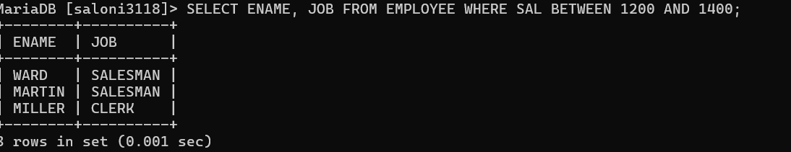

- List Name and Department Number of employee who are clerks, analyst or salesman.

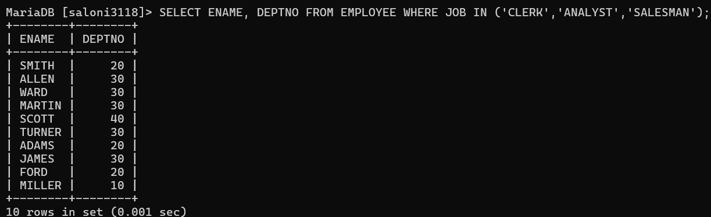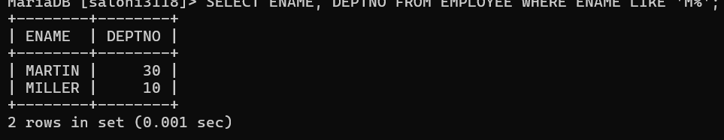

- List Name and Department Number of employee whose names began with M.



